SOURCE CODE :
import tkinter as tk
from tkinter import ttk, messagebox, simpledialog
import json
import os
from datetime import datetime

# ============================================================
# WATER DISTRIBUTION AND CONSUMPTION MANAGEMENT SYSTEM
# Mixed Data Structures:
# List + Tuple + Set + Dictionary
# ============================================================

# ------------------------------------------------------------
# GLOBAL DATA
# ------------------------------------------------------------

# LIST
# Each complete record is stored as a tuple inside this list.
records = []

# SET
# Used to maintain unique zones.
unique_zones = set()

# SET
# Used to maintain unique consumption classifications.
consumption_categories = set()

# DICTIONARY
# Stores a quick household/building-wise reference.
user_directory = {}

# DICTIONARY
# Stores zone-wise consumption totals.
zone_consumption = {}

DATA_FILE = "water_records.json"
REPORT_FILE = "water_analysis_report.txt"

# Consumption thresholds
LOW_LIMIT = 500
MODERATE_LIMIT = 1000
EXCESSIVE_LIMIT = 1000

# ------------------------------------------------------------
# RECORD FORMAT
# ------------------------------------------------------------
# Tuple structure:
#
# (
# ID,
# Zone,
# Water Supplied,
# Water Consumed,
# Date,
# Classification
# )
#
# Example:
# ("H001", "North", 1500.0, 700.0, "01-09-2026", "Moderate Consumption")
# ------------------------------------------------------------

# ------------------------------------------------------------
# VALIDATION FUNCTIONS
# ------------------------------------------------------------

def clean_text(value):
"""Remove unnecessary spaces from text."""
return value.strip()

def validate_id(value):
value = clean_text(value)

if value == "":
return False, "Household/Building ID cannot be empty."

if len(value) < 2:
return False, "ID must contain at least 2 characters."

return True, value.upper()

def validate_zone(value):
value = clean_text(value)

if value == "":
return False, "Zone cannot be empty."

if not any(char.isalpha() for char in value):
return False, "Zone must contain letters."

return True, value.title()

def validate_quantity(value, field_name):
try:
number = float(value)

if number < 0:
return False, field_name + " cannot be negative."

return True, number

except ValueError:
return False, field_name + " must be a valid number."

def validate_date(value):
value = clean_text(value)

try:
datetime.strptime(value, "%d-%m-%Y")
return True, value
except ValueError:
return False, "Date must be in DD-MM-YYYY format."

# ------------------------------------------------------------
# CONSUMPTION CLASSIFICATION
# ------------------------------------------------------------

def classify_consumption(amount):

if amount <= LOW_LIMIT:
return "Low Consumption"

elif amount <= MODERATE_LIMIT:
return "Moderate Consumption"

else:
return "High Consumption"

# ------------------------------------------------------------
# REBUILD DATA STRUCTURES
# ------------------------------------------------------------

def rebuild_indexes():

global unique_zones
global consumption_categories
global user_directory
global zone_consumption

unique_zones = set()
consumption_categories = set()
user_directory = {}
zone_consumption = {}

for record in records:

user_id, zone, supplied, consumed, date, category = record

# SET
unique_zones.add(zone)

# SET
consumption_categories.add(category)

# DICTIONARY
user_directory[user_id] = {
"zone": zone,
"supplied": supplied,
"consumed": consumed,
"date": date,
"category": category
}

# DICTIONARY
if zone not in zone_consumption:
zone_consumption[zone] = 0

zone_consumption[zone] += consumed

# ------------------------------------------------------------
# ADD RECORD
# ------------------------------------------------------------

def add_record():

record_window = tk.Toplevel(root)
record_window.title("Add Water Distribution Record")
record_window.geometry("450x430")
record_window.resizable(False, False)

frame = ttk.Frame(record_window, padding=25)
frame.pack(fill="both", expand=True)

ttk.Label(
frame,
text="ADD WATER RECORD",
font=("Arial", 18, "bold")
).pack(pady=(0, 20))

fields = {}

field_names = [
("Household / Building ID", "id"),
("Area / Zone", "zone"),
("Water Supplied (Litres)", "supplied"),
("Water Consumed (Litres)", "consumed"),
("Date (DD-MM-YYYY)", "date")
]

for label_text, key in field_names:

row = ttk.Frame(frame)
row.pack(fill="x", pady=7)

ttk.Label(
row,
text=label_text,
width=25
).pack(side="left")

entry = ttk.Entry(row)
entry.pack(side="right", expand=True, fill="x")

fields[key] = entry

def save_new_record():

valid, user_id = validate_id(fields["id"].get())

if not valid:
messagebox.showerror("Invalid ID", user_id)
return

valid, zone = validate_zone(fields["zone"].get())

if not valid:
messagebox.showerror("Invalid Zone", zone)
return

valid, supplied = validate_quantity(
fields["supplied"].get(),
"Water supplied"
)

if not valid:
messagebox.showerror("Invalid Quantity", supplied)
return

valid, consumed = validate_quantity(
fields["consumed"].get(),
"Water consumed"
)

if not valid:
messagebox.showerror("Invalid Quantity", consumed)
return

if consumed > supplied:
messagebox.showerror(
"Invalid Record",
"Water consumed cannot be greater than water supplied."
)
return

valid, date = validate_date(fields["date"].get())

if not valid:
messagebox.showerror("Invalid Date", date)
return

# Check duplicate ID
for existing in records:

if existing[0] == user_id:
messagebox.showerror(
"Duplicate ID",
"This household/building ID already exists."
)
return

category = classify_consumption(consumed)

# TUPLE
new_record = (
user_id,
zone,
supplied,
consumed,
date,
category
)

# LIST
records.append(new_record)

rebuild_indexes()

save_data()

update_dashboard()

messagebox.showinfo(
"Success",
"Water record added successfully."
)

record_window.destroy()

ttk.Button(
frame,
text="Save Record",
command=save_new_record
).pack(pady=20)

# ------------------------------------------------------------
# DISPLAY RECORDS
# ------------------------------------------------------------

def display_records():

window = tk.Toplevel(root)
window.title("Water Distribution Records")
window.geometry("950x520")

ttk.Label(
window,
text="ALL WATER RECORDS",
font=("Arial", 18, "bold")
).pack(pady=15)

columns = (
"ID",
"Zone",
"Supplied",
"Consumed",
"Date",
"Classification"
)

tree = ttk.Treeview(
window,
columns=columns,
show="headings"
)

for column in columns:

tree.heading(column, text=column)

tree.column(
column,
width=140,
anchor="center"
)

tree.pack(
fill="both",
expand=True,
padx=15,
pady=10
)

for record in records:

tree.insert(
"",
"end",
values=(
record[0],
record[1],
f"{record[2]:.2f} L",
f"{record[3]:.2f} L",
record[4],
record[5]
)
)

# ------------------------------------------------------------
# SEARCH RECORDS
# ------------------------------------------------------------

def search_records():

window = tk.Toplevel(root)
window.title("Search Water Records")
window.geometry("850x500")

ttk.Label(
window,
text="SEARCH RECORDS",
font=("Arial", 18, "bold")
).pack(pady=15)

control = ttk.Frame(window)
control.pack(pady=10)

ttk.Label(
control,
text="Search by:"
).pack(side="left", padx=5)

search_type = ttk.Combobox(
control,
values=["ID", "Zone", "Date"],
state="readonly",
width=12
)

search_type.current(0)
search_type.pack(side="left", padx=5)

search_entry = ttk.Entry(control, width=30)
search_entry.pack(side="left", padx=5)

columns = (
"ID",
"Zone",
"Supplied",
"Consumed",
"Date",
"Classification"
)

tree = ttk.Treeview(
window,
columns=columns,
show="headings"
)

for column in columns:

tree.heading(column, text=column)
tree.column(column, width=125, anchor="center")

tree.pack(
fill="both",
expand=True,
padx=15,
pady=10
)

def perform_search():

for item in tree.get_children():
tree.delete(item)

keyword = clean_text(search_entry.get()).lower()

if keyword == "":
messagebox.showwarning(
"Search",
"Enter something to search."
)
return

option = search_type.get()

for record in records:

if option == "ID":
value = record[0]

elif option == "Zone":
value = record[1]

else:
value = record[4]

if keyword in value.lower():

tree.insert(
"",
"end",
values=(
record[0],
record[1],
f"{record[2]:.2f} L",
f"{record[3]:.2f} L",
record[4],
record[5]
)
)

ttk.Button(
control,
text="Search",
command=perform_search
).pack(side="left", padx=5)

# ------------------------------------------------------------
# UPDATE RECORD
# ------------------------------------------------------------

def update_record():

if not records:

messagebox.showinfo(
"Update",
"No records available."
)
return

user_id = simpledialog.askstring(
"Update Record",
"Enter Household/Building ID:"
)

if not user_id:
return

user_id = user_id.strip().upper()

index = -1

for i, record in enumerate(records):

if record[0] == user_id:
index = i
break

if index == -1:

messagebox.showerror(
"Not Found",
"Record not found."
)
return

old_record = records[index]

new_zone = simpledialog.askstring(
"Update",
"Enter zone:",
initialvalue=old_record[1]
)

new_supplied = simpledialog.askstring(
"Update",
"Enter water supplied:",
initialvalue=str(old_record[2])
)

new_consumed = simpledialog.askstring(
"Update",
"Enter water consumed:",
initialvalue=str(old_record[3])
)

new_date = simpledialog.askstring(
"Update",
"Enter date DD-MM-YYYY:",
initialvalue=old_record[4]
)

valid, zone = validate_zone(new_zone)

if not valid:
messagebox.showerror("Error", zone)
return

valid, supplied = validate_quantity(
new_supplied,
"Water supplied"
)

if not valid:
messagebox.showerror("Error", supplied)
return

valid, consumed = validate_quantity(
new_consumed,
"Water consumed"
)

if not valid:
messagebox.showerror("Error", consumed)
return

if consumed > supplied:

messagebox.showerror(
"Error",
"Consumption cannot exceed supplied water."
)
return

valid, date = validate_date(new_date)

if not valid:
messagebox.showerror("Error", date)
return

category = classify_consumption(consumed)

# Replace tuple in LIST
records[index] = (
user_id,
zone,
supplied,
consumed,
date,
category
)

rebuild_indexes()
save_data()
update_dashboard()

messagebox.showinfo(
"Updated",
"Record updated successfully."
)

# ------------------------------------------------------------
# CLASSIFICATION VIEW
# ------------------------------------------------------------

def show_classification():

window = tk.Toplevel(root)
window.title("Consumption Classification")
window.geometry("800x500")

ttk.Label(
window,
text="CONSUMPTION CLASSIFICATION",
font=("Arial", 18, "bold")
).pack(pady=15)

columns = (
"ID",
"Zone",
"Consumption",
"Category"
)

tree = ttk.Treeview(
window,
columns=columns,
show="headings"
)

for column in columns:

tree.heading(column, text=column)
tree.column(column, width=180, anchor="center")

tree.pack(
fill="both",
expand=True,
padx=20,
pady=10
)

for record in records:

tree.insert(
"",
"end",
values=(
record[0],
record[1],
f"{record[3]:.2f} L",
record[5]
)
)

# ------------------------------------------------------------
# ANALYSIS CALCULATIONS
# ------------------------------------------------------------

def calculate_analysis():

total_supplied = sum(
record[2] for record in records
)

total_consumed = sum(
record[3] for record in records
)

remaining = total_supplied - total_consumed

if records:

average = total_consumed / len(records)

else:

average = 0

if total_supplied > 0:

percentage = (
total_consumed / total_supplied
) * 100

else:

percentage = 0

high_users = [
record for record in records
if record[3] > EXCESSIVE_LIMIT
]

return (
total_supplied,
total_consumed,
remaining,
average,
percentage,
high_users
)

# ------------------------------------------------------------
# WATER ANALYSIS
# ------------------------------------------------------------

def show_analysis():

window = tk.Toplevel(root)
window.title("Water Analysis")
window.geometry("700x600")

ttk.Label(
window,
text="WATER ANALYSIS",
font=("Arial", 20, "bold")
).pack(pady=20)

(
total_supplied,
total_consumed,
remaining,
average,
percentage,
high_users
) = calculate_analysis()

values = [
("Total Water Supplied", total_supplied),
("Total Water Consumed", total_consumed),
("Remaining Water", remaining),
("Average Consumption", average),
("Consumption Percentage", percentage)
]

for name, value in values:

card = ttk.Frame(
window,
relief="ridge",
borderwidth=2
)

card.pack(
fill="x",
padx=50,
pady=8
)

if name == "Consumption Percentage":

display_value = f"{value:.2f}%"

else:

display_value = f"{value:.2f} L"

ttk.Label(
card,
text=name,
font=("Arial", 11)
).pack(
side="left",
padx=15,
pady=15
)

ttk.Label(
card,
text=display_value,
font=("Arial", 12, "bold")
).pack(
side="right",
padx=15
)

ttk.Label(
window,
text=f"High Consumption Users: {len(high_users)}",
font=("Arial", 13, "bold")
).pack(pady=20)

# ------------------------------------------------------------
# EXCESSIVE CONSUMPTION
# ------------------------------------------------------------

def excessive_consumption():

window = tk.Toplevel(root)
window.title("Excessive Consumption")
window.geometry("850x500")

ttk.Label(
window,
text="EXCESSIVE WATER CONSUMPTION",
font=("Arial", 18, "bold")
).pack(pady=15)

ttk.Label(
window,
text=f"Consumption limit: {EXCESSIVE_LIMIT} L"
).pack()

columns = (
"ID",
"Zone",
"Consumed",
"Date",
"Category"
)

tree = ttk.Treeview(
window,
columns=columns,
show="headings"
)

for column in columns:

tree.heading(column, text=column)
tree.column(column, width=150, anchor="center")

tree.pack(
fill="both",
expand=True,
padx=20,
pady=20
)

found = False

for record in records:

if record[3] > EXCESSIVE_LIMIT:

found = True

tree.insert(
"",
"end",
values=(
record[0],
record[1],
f"{record[3]:.2f} L",
record[4],
record[5]
)
)

if not found:

ttk.Label(
window,
text="No excessive consumption detected."
).pack(pady=10)

# ------------------------------------------------------------
# ZONE-WISE ANALYSIS
# ------------------------------------------------------------

def zone_analysis():

rebuild_indexes()

window = tk.Toplevel(root)
window.title("Zone-wise Analysis")
window.geometry("700x500")

ttk.Label(
window,
text="ZONE-WISE WATER CONSUMPTION",
font=("Arial", 18, "bold")
).pack(pady=20)

columns = (
"Zone",
"Total Consumption",
"Users"
)

tree = ttk.Treeview(
window,
columns=columns,
show="headings"
)

for column in columns:

tree.heading(column, text=column)
tree.column(column, width=200, anchor="center")

tree.pack(
fill="both",
expand=True,
padx=30,
pady=20
)

for zone in sorted(zone_consumption):

users = 0

for record in records:

if record[1] == zone:
users += 1

tree.insert(
"",
"end",
values=(
zone,
f"{zone_consumption[zone]:.2f} L",
users
)
)

# ------------------------------------------------------------
# UNIQUE DATA ANALYSIS
# ------------------------------------------------------------

def unique_data():

rebuild_indexes()

window = tk.Toplevel(root)
window.title("Unique Data Analysis")
window.geometry("650x500")

ttk.Label(
window,
text="UNIQUE DATA ANALYSIS",
font=("Arial", 18, "bold")
).pack(pady=20)

# SETS
user_ids = {
record[0] for record in records
}

zones = {
record[1] for record in records
}

categories = {
record[5] for record in records
}

information = [
("Unique Users / Buildings", user_ids),
("Unique Zones", zones),
("Consumption Categories", categories)
]

for title, data in information:

ttk.Label(
window,
text=title,
font=("Arial", 12, "bold")
).pack(anchor="w", padx=30, pady=(15, 5))

text = ", ".join(sorted(data)) if data else "None"

ttk.Label(
window,
text=text,
wraplength=550
).pack(anchor="w", padx=45)

# ------------------------------------------------------------
# SAVE DATA
# ------------------------------------------------------------

def save_data():

try:

# Convert tuples to lists because JSON does not
# have a native tuple type.
serializable_records = [
list(record) for record in records
]

with open(
DATA_FILE,
"w",
encoding="utf-8"
) as file:

json.dump(
serializable_records,
file,
indent=4
)

return True

except Exception as error:

messagebox.showerror(
"Save Error",
str(error)
)

return False

# ------------------------------------------------------------
# LOAD DATA
# ------------------------------------------------------------

def load_data():

global records

if not os.path.exists(DATA_FILE):
return

try:

with open(
DATA_FILE,
"r",
encoding="utf-8"
) as file:

stored_records = json.load(file)

records = []

# Convert loaded lists back into TUPLES.
for item in stored_records:

records.append(
(
item[0],
item[1],
float(item[2]),
float(item[3]),
item[4],
item[5]
)
)

rebuild_indexes()

except Exception as error:

messagebox.showerror(
"Load Error",
str(error)
)

# ------------------------------------------------------------
# GENERATE ANALYTICAL REPORT
# ------------------------------------------------------------

def generate_report():

if not records:

messagebox.showinfo(
"Report",
"No records available to generate a report."
)
return

(
total_supplied,
total_consumed,
remaining,
average,
percentage,
high_users
) = calculate_analysis()

rebuild_indexes()

report = []

report.append(
"WATER DISTRIBUTION AND CONSUMPTION ANALYTICAL REPORT"
)

report.append("=" * 60)

report.append(
f"Generated on: {datetime.now().strftime('%d-%m-%Y %H:%M:%S')}"
)

report.append("")

report.append("OVERALL ANALYSIS")
report.append("-" * 30)

report.append(
f"Total Water Supplied : {total_supplied:.2f} L"
)

report.append(
f"Total Water Consumed : {total_consumed:.2f} L"
)

report.append(
f"Remaining Water : {remaining:.2f} L"
)

report.append(
f"Average Consumption : {average:.2f} L"
)

report.append(
f"Consumption Percentage : {percentage:.2f}%"
)

report.append("")

report.append("ZONE-WISE ANALYSIS")
report.append("-" * 30)

for zone in sorted(zone_consumption):

report.append(
f"{zone}: {zone_consumption[zone]:.2f} L"
)

report.append("")

report.append("EXCESSIVE CONSUMPTION")
report.append("-" * 30)

if high_users:

for record in high_users:

report.append(
f"{record[0]} | "
f"{record[1]} | "
f"{record[3]:.2f} L"
)

else:

report.append("No excessive consumption detected.")

report.append("")

report.append("UNIQUE ZONES")
report.append("-" * 30)

report.append(
", ".join(sorted(unique_zones))
)

report.append("")

report.append("UNIQUE CONSUMPTION CATEGORIES")
report.append("-" * 30)

report.append(
", ".join(sorted(consumption_categories))
)

report.append("")
report.append("=" * 60)

try:

with open(
REPORT_FILE,
"w",
encoding="utf-8"
) as file:

file.write("\n".join(report))

messagebox.showinfo(
"Report Generated",
f"Analytical report saved as:\n{REPORT_FILE}"
)

except Exception as error:

messagebox.showerror(
"Report Error",
str(error)
)

# ------------------------------------------------------------
# DASHBOARD UPDATE
# ------------------------------------------------------------

def update_dashboard():

(
total_supplied,
total_consumed,
remaining,
average,
percentage,
high_users
) = calculate_analysis()

supplied_value.config(
text=f"{total_supplied:,.0f} L"
)

consumed_value.config(
text=f"{total_consumed:,.0f} L"
)

remaining_value.config(
text=f"{remaining:,.0f} L"
)

percentage_value.config(
text=f"{percentage:.1f}%"
)

record_count_value.config(
text=str(len(records))
)

high_count_value.config(
text=str(len(high_users))
)

# ------------------------------------------------------------
# EXIT
# ------------------------------------------------------------

def exit_application():

save_data()
root.destroy()

# ============================================================
# MAIN GUI
# ============================================================

root = tk.Tk()

root.title(
"AquaTrack - Water Distribution & Consumption Management"
)

root.geometry("1100x720")

root.minsize(950, 650)

# ------------------------------------------------------------
# STYLE
# ------------------------------------------------------------

style = ttk.Style()

try:
style.theme_use("clam")
except:
pass

style.configure(
"Title.TLabel",
font=("Arial", 24, "bold")
)

style.configure(
"Subtitle.TLabel",
font=("Arial", 11)
)

style.configure(
"Dashboard.TButton",
font=("Arial", 11, "bold"),
padding=12
)

# ------------------------------------------------------------
# HEADER
# ------------------------------------------------------------

header = ttk.Frame(
root,
padding=20
)

header.pack(fill="x")

ttk.Label(
header,
text="AquaTrack",
style="Title.TLabel"
).pack()

ttk.Label(
header,
text="Water Distribution & Consumption Management System",
style="Subtitle.TLabel"
).pack(pady=5)

# ------------------------------------------------------------
# SUMMARY CARDS
# ------------------------------------------------------------

summary = ttk.Frame(root)

summary.pack(
fill="x",
padx=25,
pady=15
)

def create_card(parent, title):

card = ttk.Frame(
parent,
relief="ridge",
borderwidth=2,
padding=15
)

card.pack(
side="left",
expand=True,
fill="both",
padx=5
)

ttk.Label(
card,
text=title,
font=("Arial", 10)
).pack()

value = ttk.Label(
card,
text="0",
font=("Arial", 18, "bold")
)

value.pack(pady=8)

return value

supplied_value = create_card(
summary,
"TOTAL SUPPLIED"
)

consumed_value = create_card(
summary,
"TOTAL CONSUMED"
)

remaining_value = create_card(
summary,
"REMAINING"
)

percentage_value = create_card(
summary,
"CONSUMPTION"
)

# ------------------------------------------------------------
# SECONDARY SUMMARY
# ------------------------------------------------------------

secondary = ttk.Frame(root)

secondary.pack(
fill="x",
padx=25,
pady=5
)

record_count_value = create_card(
secondary,
"TOTAL RECORDS"
)

high_count_value = create_card(
secondary,
"HIGH CONSUMPTION"
)

# ------------------------------------------------------------
# MENU BUTTONS
# ------------------------------------------------------------

menu_frame = ttk.Frame(
root,
padding=20
)

menu_frame.pack(
fill="both",
expand=True
)

ttk.Label(
menu_frame,
text="SYSTEM OPERATIONS",
font=("Arial", 15, "bold")
).pack(pady=(5, 15))

button_grid = ttk.Frame(menu_frame)

button_grid.pack()

buttons = [
("Add Water Record", add_record),
("Update Record", update_record),
("Display Records", display_records),
("Search Records", search_records),
("Consumption Classification", show_classification),
("Water Analysis", show_analysis),
("Excessive Consumption", excessive_consumption),
("Zone-wise Analysis", zone_analysis),
("Unique Data Analysis", unique_data),
("Save Records", save_data),
("Generate Report", generate_report)
]

for index, (text, command) in enumerate(buttons):

row = index // 3
column = index % 3

ttk.Button(
button_grid,
text=text,
command=command,
style="Dashboard.TButton",
width=27
).grid(
row=row,
column=column,
padx=8,
pady=8
)

# ------------------------------------------------------------
# FOOTER
# ------------------------------------------------------------

footer = ttk.Frame(
root,
padding=10
)

footer.pack(fill="x")

ttk.Button(
footer,
text="Exit",
command=exit_application
).pack()

# ------------------------------------------------------------
# LOAD PREVIOUS DATA
# ------------------------------------------------------------

load_data()

update_dashboard()

# ------------------------------------------------------------
# START APPLICATION
# ------------------------------------------------------------

root.protocol(
"WM_DELETE_WINDOW",
exit_application
)

root.mainloop()

OUTPUT:

Display records:

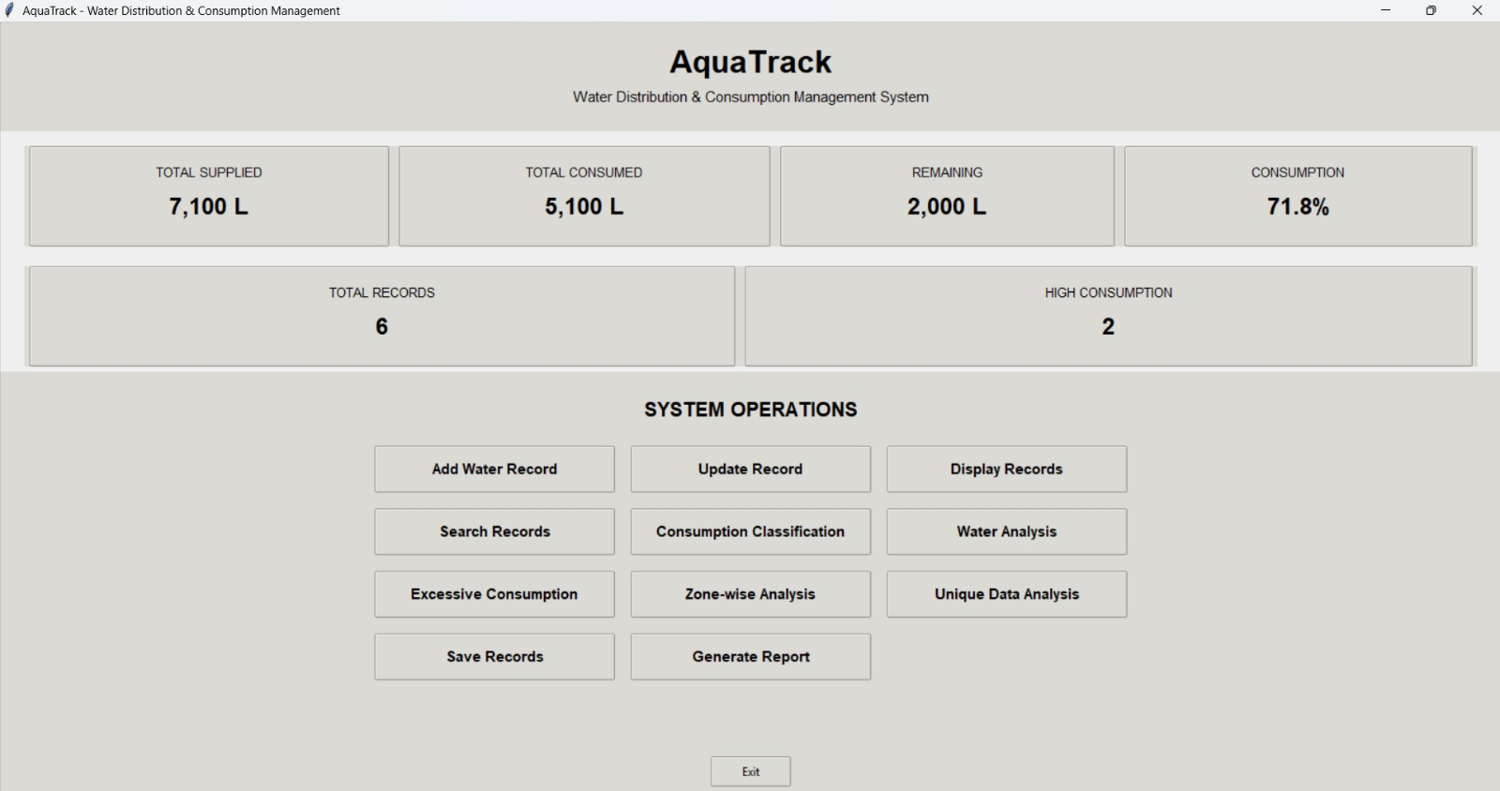
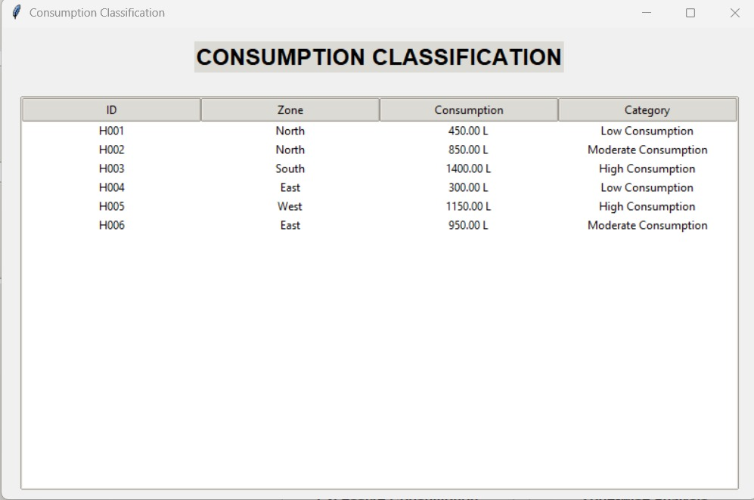
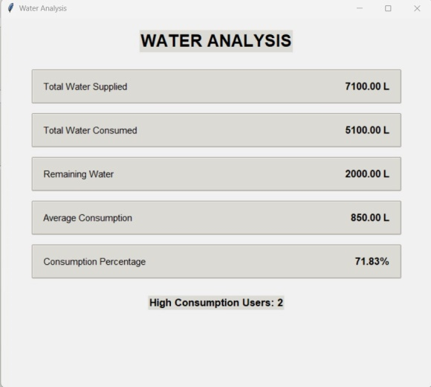
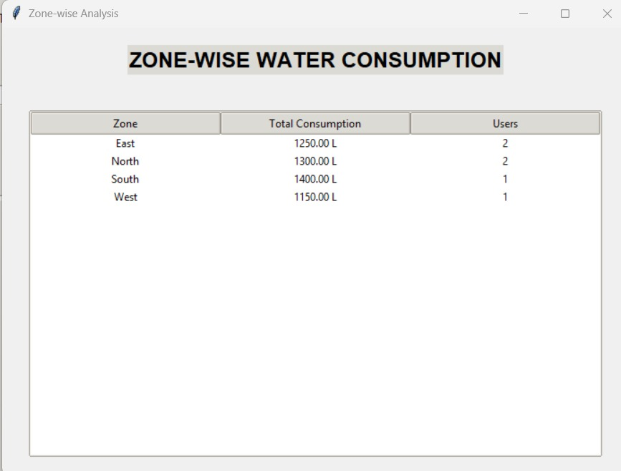
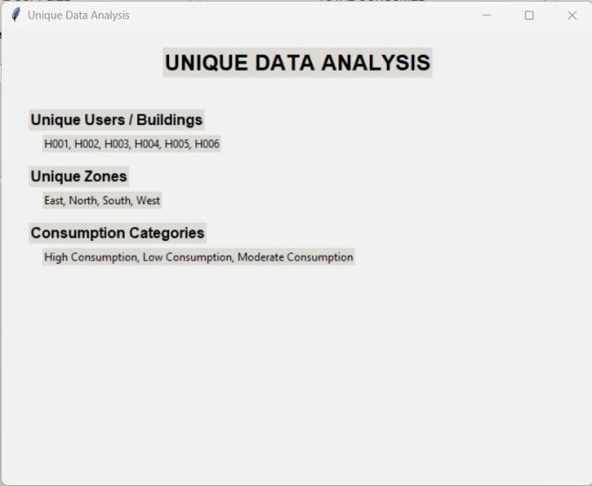
Water analysis report:

